Mid paper

You are tasked with troubleshooting connectivity in a small
network with two routers (R1, R2),
each connected to a PC (PC1 and PC2, respectively).

- Step
1: Create a topology with two routers connected via a serial interface.
- Step
2: Connect PC1 to R1’s LAN and PC2 to R2’s LAN.
- Step
3: Assign IP addresses:
- Step
4: Configure static routing on both routers for end-to-end communication.
- Step
5: Use the ping command from PC1 to PC2. Observe ICMP replies and analyze
what happens if a route is missing.
Deliverables: Screenshot of the ping test, static routing commands, and
an explanation of how ICMP helps detect network issues.

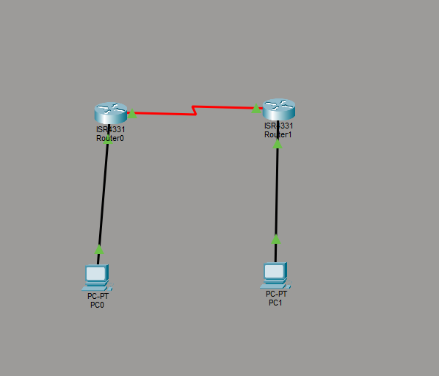

R1 Config
enable
configure terminal

interface GigabitEthernet0/0/0
ip address 192.168.0.254 255.255.255.0
no shutdown

interface Serial0/1/0
ip address 10.0.0.1 255.255.255.252
no shutdown

ip route 192.168.100.0 255.255.255.0 10.0.0.2

R2 config

enable
configure terminal

interface GigabitEthernet0/0/0
ip address 192.168.100.254 255.255.255.0
no shutdown

interface Serial0/1/0
ip address 10.0.0.2 255.255.255.252
no shutdown

ip route 192.168.0.0 255.255.255.0 10.0.0.1

A basic topology diagram is provided
showing a router, a switch, PCs, and Laptops.
Tasks:
A.
Configure DHCP on the router so that all PCs receive
IP addresses automatically.
B.
Verify successful IP assignment on each PC and test
connectivity between them using ping.
Include screenshots of
the DHCP pool, IP configurations, and ping results in your report.
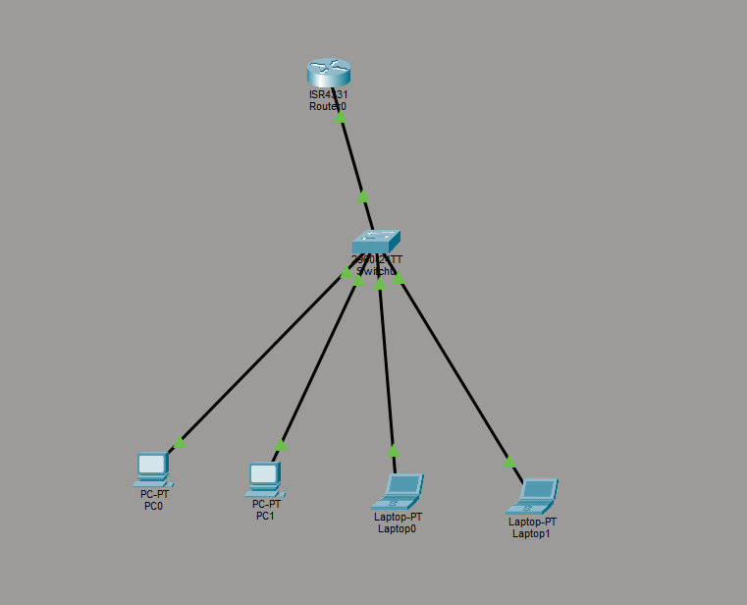

enable
configure terminal

interface GigabitEthernet0/0/0
ip address 192.168.1.1 255.255.255.0
no shutdown

ip dhcp pool LAN_POOL
network 192.168.1.0 255.255.255.0
default-router 192.168.1.1
dns-server 8.8.8.8

ip dhcp excluded-address 192.168.1.1

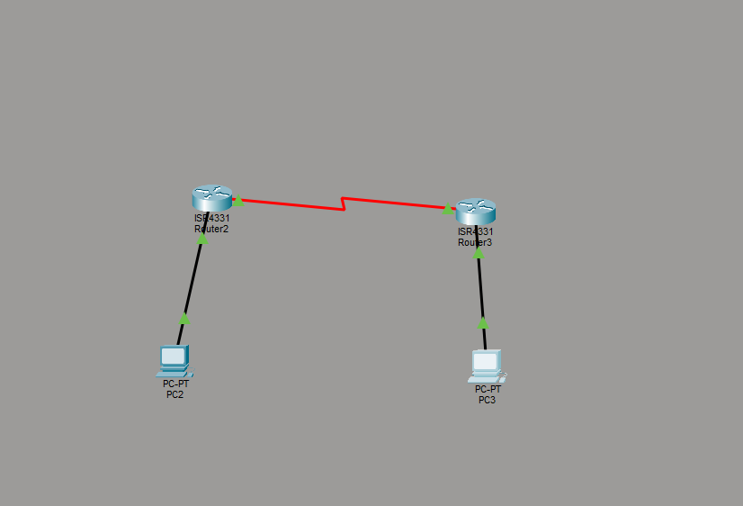

R1> enable
R1# configure terminal

! PC1 network
R1(config)# interface Gig0/0/0
R1(config-if)# ip address 10.0.0.1 255.0.0.0
R1(config-if)# no shutdown

! Link to R2
R1(config)# interface Serial0/0
R1(config-if)# ip address 192.168.12.1 255.255.255.0
R1(config-if)# no shutdown
R1(config)# router rip
R1(config-router)# version 2
R1(config-router)# no auto-summary
R1(config-router)# network 10.0.0.0
R1(config-router)# network 20.0.0.0
R1(config-router)# network 192.168.12.0

R1> enable
R1# configure terminal

! PC1 network
R1(config)# interface Gig0/0/0
R1(config-if)# ip address 10.0.0.1 255.0.0.0
R1(config-if)# no shutdown

! PC2 network
R1(config)# interface Gig0/0/1
R1(config-if)# ip address 20.0.0.1 255.0.0.0
R1(config-if)# no shutdown

! Link to R2
R1(config)# interface Serial0/0
R1(config-if)# ip address 192.168.12.1 255.255.255.0
R1(config-if)# no shutdown

R2(config)# router rip
R2(config-router)# version 2
R2(config-router)# no auto-summary
R2(config-router)# network 30.0.0.0
R2(config-router)# network 192.168.12.0

R1# show ip interface brief
R2# show ip interface brief

R1# do show ip route
R2# do show ip route

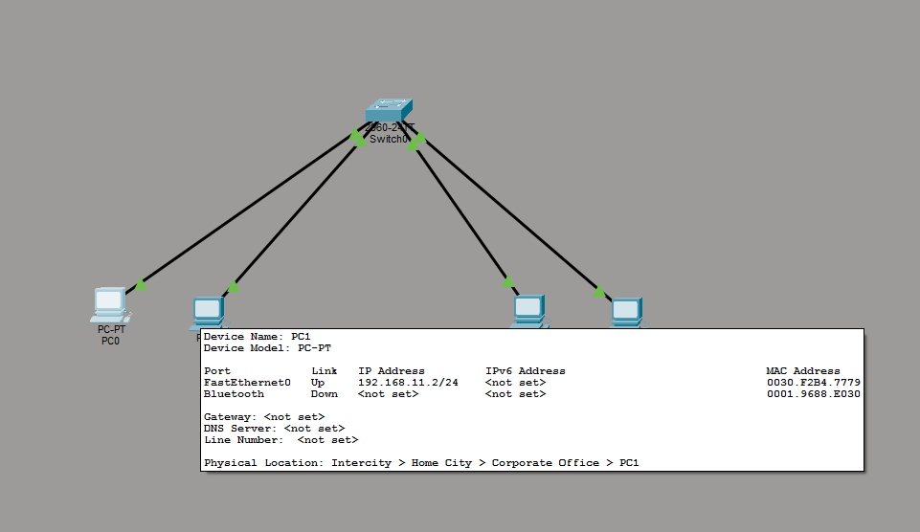

You need 1 switch and 4 PCs (simplest approach):
- PC1 and PC2 → Floor 1 → VLAN 11 → 192.168.11.0/24
- PC3 and PC4 → Floor 2 → VLAN 12 → 192.168.12.0/24

Configure VLANs on the Switch
Enter VLAN configuration

Switch> enable
Switch# configure terminal
Switch(config)# vlan 11
Switch(config-vlan)# name Floor1
Switch(config-vlan)# exit

Switch(config)# vlan 12
Switch(config-vlan)# name Floor2
Switch(config-vlan)# exit

Switch(config)# interface range fa0/1 - 2
Switch(config-if-range)# switchport mode access
Switch(config-if-range)# switchport access vlan 11
Switch(config-if-range)# exit

Switch(config)# interface range fa0/3 - 4
Switch(config-if-range)# switchport mode access
Switch(config-if-range)# switchport access vlan 12
Switch(config-if-range)# exit

Step 5: Assign IP Addresses to PCs
- PC1 → VLAN 11
  - IP: 192.168.11.10
  - Subnet mask: 255.255.255.0
- PC2 → VLAN 11
  - IP: 192.168.11.11
  - Subnet mask: 255.255.255.0
- PC3 → VLAN 12
  - IP: 192.168.12.10
  - Subnet mask: 255.255.255.0
- PC4 → VLAN 12
  - IP: 192.168.12.11
  - Subnet mask: 255.255.255.0
Note: No default gateway is needed if VLANs are not routing between each other.

